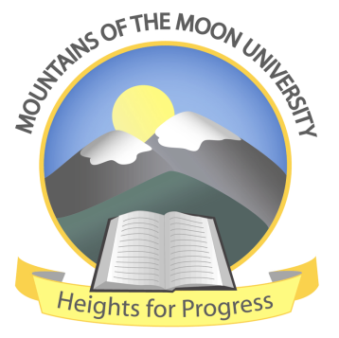
MOUNTAINS OF THE MOON UNIVERSITY

OFFICE OF MARKETING AND PUBLIC RELATIONS

NEWS FOR WEBSITE

Date: 23rd August 2022

Dispelling the false news on reporting date for Semester I, 2022/23

Mountains of the Moon University refutes false news circulating in the section of the online papers indicating that first-year students of Academic Year 2022/2023 date for Semester I reporting is 15th September 2022. This is NOT true and is unfounded.

According to the planned activities of the Office of the Academic Registrar, the date set for reporting of first-years for Academic Year 2022/2023 Semester I is 5th September 2022 and the orientation week for the 1st year runs from 5th – 9th September 2022.

This is to dispel the false news and encourage all the admitted students of Mountains of the Moon University academic year 2022/23 to continue picking their admission letters and prepare for the semester I studies that start on 5th September 2022.

Heights For Progress

Brens Willie Wambedde
Communications & Public Relations Officer

