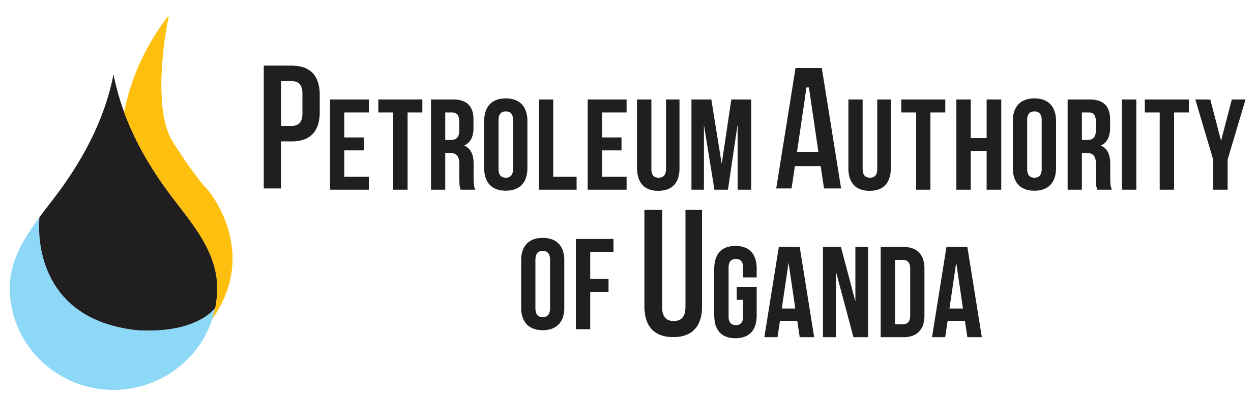

REMARKS

AT

SIGNING OF A MEMORANDUM OF UNDERSTANDING BETWEEN TOTALENERGIES EP UGANDA AND MAKERERE UNIVERSITY

16th AUGUST 2022

MUK ROTARY PEACE CENTRE, KAMPALA
- The Petroleum Authority of Uganda is glad to be part of this event to cement the partnership between Makerere University and TotalEnergies EP Uganda, and by wider implication, the Oil and Gas industry.

- I extend greetings from the Executive Director of the Petroleum Authority of Uganda who was not able to attend this event due to another equally very important engagement.

- On behalf of the Petroleum Authority of Uganda and my own behalf as an alumnus of this great institution, to congratulate Makerere university on attaining of a century of excellence in building a transformed society. Indeed, Uganda’s premier geoscientists, responsible for discovery and confirmation of commercial oil and gas resources in Uganda, and the key milestones, thereafter, were trained at Makerere University.

- I therefore congratulate you, and commend the effort taken in achieving your vision of building for the future, specifically as it relates to the oil and gas sector.

- Today’s milestone, therefore, builds on these achievements. The MoU creates a framework of collaboration on diverse segments, projects, and subjects.

- The recent announcement of the Final Investment Decision (FID) has opened immense opportunities, specifically for employment and skills development. Therefore, the role of higher institutions of learning in delivering part of the required workforce cannot be over emphasized.

- The Petroleum Authority of Uganda’s mission focuses of creating lasting value to society. One of the ways to achieve this is supporting partnerships, such as the one between TotalEnergies and MUK, that goes beyond enhancing the participation of Ugandans in the oil and gas activities, to contributing to the Sustainable Development Goal on Quality Education, through Youth Inclusion. TotalEnergies EP Uganda will also sign an agreement with the University to provide support towards outfitting the Emergency Medical Skills Training Centre at Makerere University College of Health Sciences.

- This lasting value will be attained, by among others, harnessing the linkages between the oil sector and other growth sectors of the economy such as education and health, together with agriculture, manufacturing, tourism and land use planning. The estimated value of these linkages, prior to first oil/ commercial oil production, is close to US$ 9 billion.

- We thank the management of TotalEnergies for choosing Makerere University, and trust that the stellar academic reputation, improving infrastructure and highly trained/ skilled staff will ensure attainment of the stated objectives.

- This initiative compliments existing efforts to support the University on its journey and some of the initiatives so far undertaken include;
- Equipping of a Petroleum Geoscience laboratory by Schlumbeger.
- Collaboration with Makerere University to review the University’s curriculum for oil and gas and ensure that the content is rich and relevant for the oil and gas sector in Uganda.
- Supported a number of universities in the signing an MOUs with Ellis for Paleoscan software used in seismic data interpretation which will see Makerere University receive at least 25 software licenses and the number can be gradually increased so that more students and staff get the required skills.
- Supported numerous field visits for the Makerere Petroleum and Geology Students (MPGS) association to provide exposure to the students on the ongoing work programmes.

- To further promote the employment of Ugandans, the Petroleum Authority of Uganda has established the National Oil and Gas Talent Register. This is an online register that promotes the visibility of the available talent in the country for employability. This register currently has over 100 companies registered to solicit for talent and over 7000 Ugandans with varying skills.

Conclusion
- We thank the management of Makerere University for sustaining the high standard at the Institute that has enabled you win the confidence of the Joint Venture Partners.

- I thank TotalEnergies EP Uganda for the invitation and for contributing enhancing the capacity of Ugandans with the requisite qualifications to work in the Oil and Gas, and other sectors of the economy. In the same vein, I extend an invitation to the numerous licensees, contractors, and subcontractors to continue supporting higher education at all levels.

- I congratulate the students who have been selected to undertake this course. I encourage you to treat the program with utmost seriousness, and to register on the National Oil and Gas Talent Register

I thank you for God and My Country.

